Our Wednesday session hosted a special Birthday celebration for long standing member, Beryl Tarttelin
With our warmest wishes and heartfelt thanks
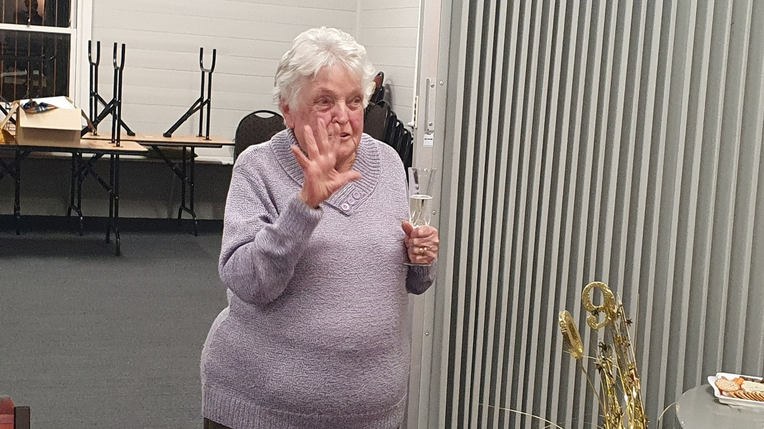
On the very special occasion of your 90th birthday, we celebrate not only this wonderful milestone,
but also the enormous contribution you have made to the Bungendore Bridge Club over so many years.
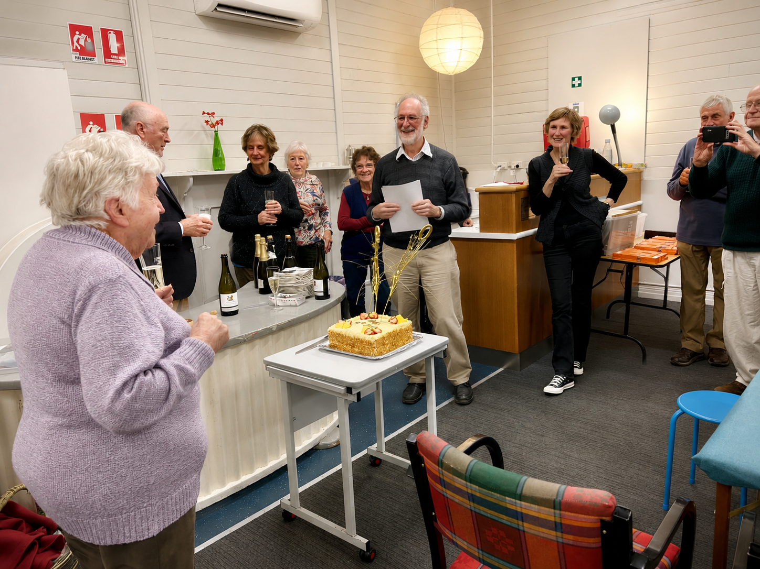
Your friendship, generosity, enthusiasm and commitment have helped make our Club the warm and welcoming place it is today.
Beyond the bridge table, your contribution to the Bungendore community has also been considerable.
You have given your time, energy and friendship freely, and touched the lives of many people along the way.
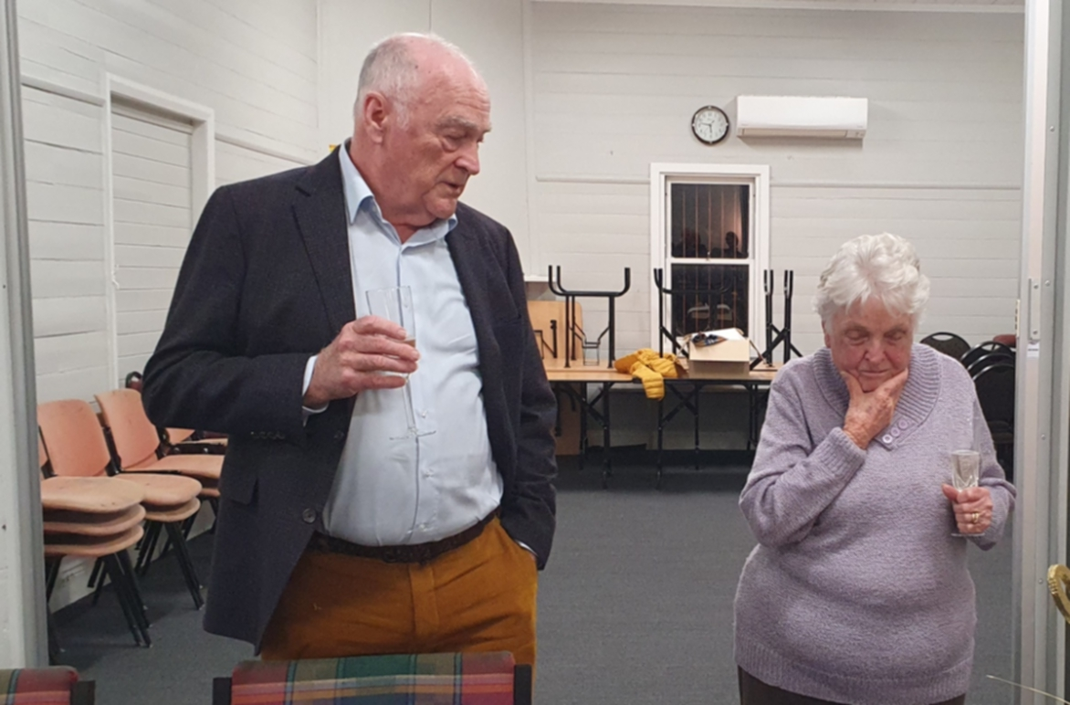
Beryl, you are a very special part of our Club and our community, and today we simply want to say:
Thank you for all you have given,
congratulations on 90 wonderful years,
and Happy Birthday!

With affection and appreciation,

Your friends at the
Bungendore Bridge Club

